SHOPEZ: A PREMIUM FULL-STACK E-COMMERCE STOREFRONT

Project Report

Submitted By
Ankith Ramadas
B.Tech – Computer Science Engineering
Anurag University

Page 1: Introduction

Introduction
The rapid expansion of online retail has increased the demand for responsive, secure, and user-friendly e-commerce platforms. Modern consumers expect seamless browsing, personalized shopping experiences, efficient order management, and secure transactions.
ShopEZ is a premium full-stack e-commerce storefront developed using the MERN stack (MongoDB, Express.js, React.js, and Node.js). The platform provides a complete online shopping ecosystem where buyers can browse products, manage shopping carts, place orders, and track deliveries. Sellers can manage inventory, monitor sales performance, and fulfill customer orders through an interactive dashboard.
The system follows a client-server architecture and incorporates modern web technologies to ensure scalability, maintainability, and security. ShopEZ demonstrates real-world software engineering practices and full-stack development concepts through practical implementation of authentication, database management, RESTful APIs, and responsive user interfaces.

Page 2: Objective and Problem Statement

Objective
The main objectives of ShopEZ are:
● To develop a modern and responsive e-commerce platform.
● To provide efficient shopping experiences for customers.
● To implement secure authentication and authorization mechanisms.
● To enable sellers to manage inventory and orders effectively.
● To provide analytical dashboards for sales monitoring.
● To demonstrate full-stack web development using MERN technologies.

Problem Statement
Traditional e-commerce systems often face several challenges:
● Complex inventory management.
● Inefficient order processing systems.
● Poor user experience and navigation.
● Security vulnerabilities in authentication.
● Lack of real-time sales monitoring for merchants.
ShopEZ addresses these challenges by implementing secure JWT authentication, modern React-based interfaces, MongoDB database integration, dynamic product management, and seller analytics dashboards.
.

Page 3: Technology Stack

Frontend Technologies

React.js
Used for developing reusable user interface components and managing application state efficiently.

React Router DOM
Provides seamless navigation between pages without full page reloads.

Axios
Handles communication between frontend and backend APIs.

Recharts
Used for generating interactive charts and sales analytics dashboards.

Lucide React Icons
Provides modern and lightweight icon components.

CSS
Custom responsive styling with modern UI components and layouts.

Backend Technologies

Node.js
Provides the runtime environment for executing server-side JavaScript.

Express.js
Handles routing, middleware management, and API development.

MongoDB
Stores application data including users, products, and orders.

Mongoose
Acts as an Object Data Modeling (ODM) library for MongoDB.

JWT Authentication
Provides secure user authentication and authorization.

BcryptJS
Ensures secure password hashing before storage.

Page 4: System Architecture

Architecture Overview
ShopEZ follows a three-tier architecture:

Presentation Layer
- React Frontend
- User Interface Components
- Routing and State Management

Business Logic Layer
- Express API Server
- Authentication Middleware
- Product, User, Order, and Admin Services

Data Layer
- MongoDB Atlas Database
- Mongoose Models
- Cloud Storage Integration

Workflow
- User sends request through frontend.
- Axios communicates with backend APIs.
- Backend validates JWT tokens.
- Data is processed using business logic.
- MongoDB stores or retrieves information.
- Response is sent back to the user interface.

Page 5: Database Design

User Collection
The User collection stores:
- Name
- Email
- Password
- Role (Buyer, Seller)

Purpose
Maintains authentication credentials and role-based permissions.

Product Collection
The Product collection stores:
- Product Name
- Description
- Price
- Category
- Image
- Stock Quantity
- Seller Information
- Reviews and Ratings

Purpose
Maintains all product-related information displayed in the catalog.

Order Collection
The Order collection stores:
- Customer Information
- Ordered Products
- Shipping Address
- Payment Details
- Order Status

Purpose
Tracks customer purchases and delivery progress.

Page 6: Features Implemented

Customer Features
- User Registration and Login
- Product Browsing
- Product Search and Filtering
- Shopping Cart Management
- Product Reviews and Ratings
- Order Placement
- Order Tracking

Seller Features
- Product Management
- Inventory Updates
- Revenue Tracking
- Order Status Updates
- Seller Dashboard

Admin Features
- User Management
- Product Management
- Order Monitoring
- Platform Statistics
- Role-Based Access Control

Security Features
- JWT Authentication
- Password Hashing using BcryptJS
- Protected Routes
- Secure API Access

Page 7: Testing, Results and Screenshots

Testing Performed

Authentication Testing
Verified login, registration, and role-based access.

Product Management Testing
Validated product creation, updates, and deletion.

Order Management Testing
Tested order placement and status updates.

Admin Dashboard Testing
Verified:
- User Management
- Product Management
- Order Monitoring
- Dashboard Statistics

Results
The application successfully:
- Connected with MongoDB Atlas.
- Performed CRUD operations.
- Managed user authentication securely.
- Processed orders accurately.
- Supported customer, seller, and admin roles.

Screenshots Included

1. Home Page
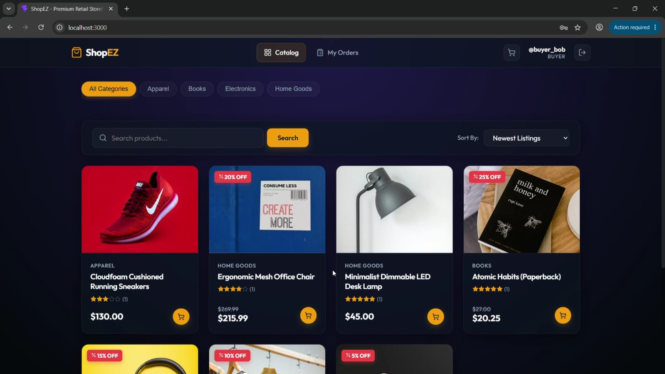

2. Catalog
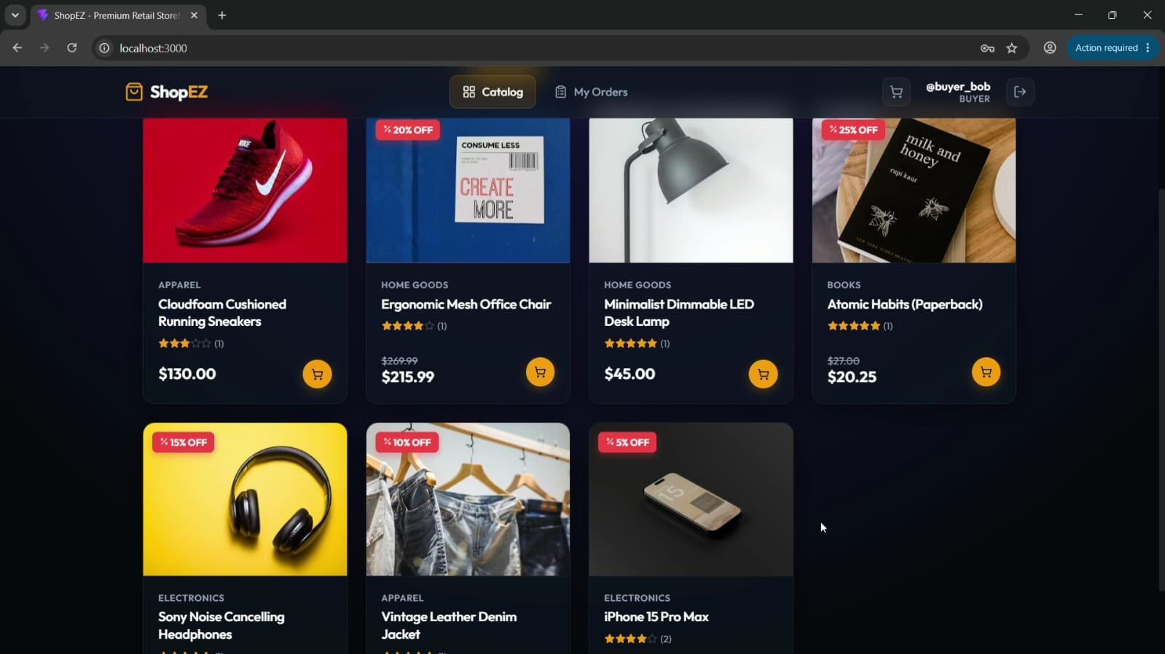

3. Product Details Page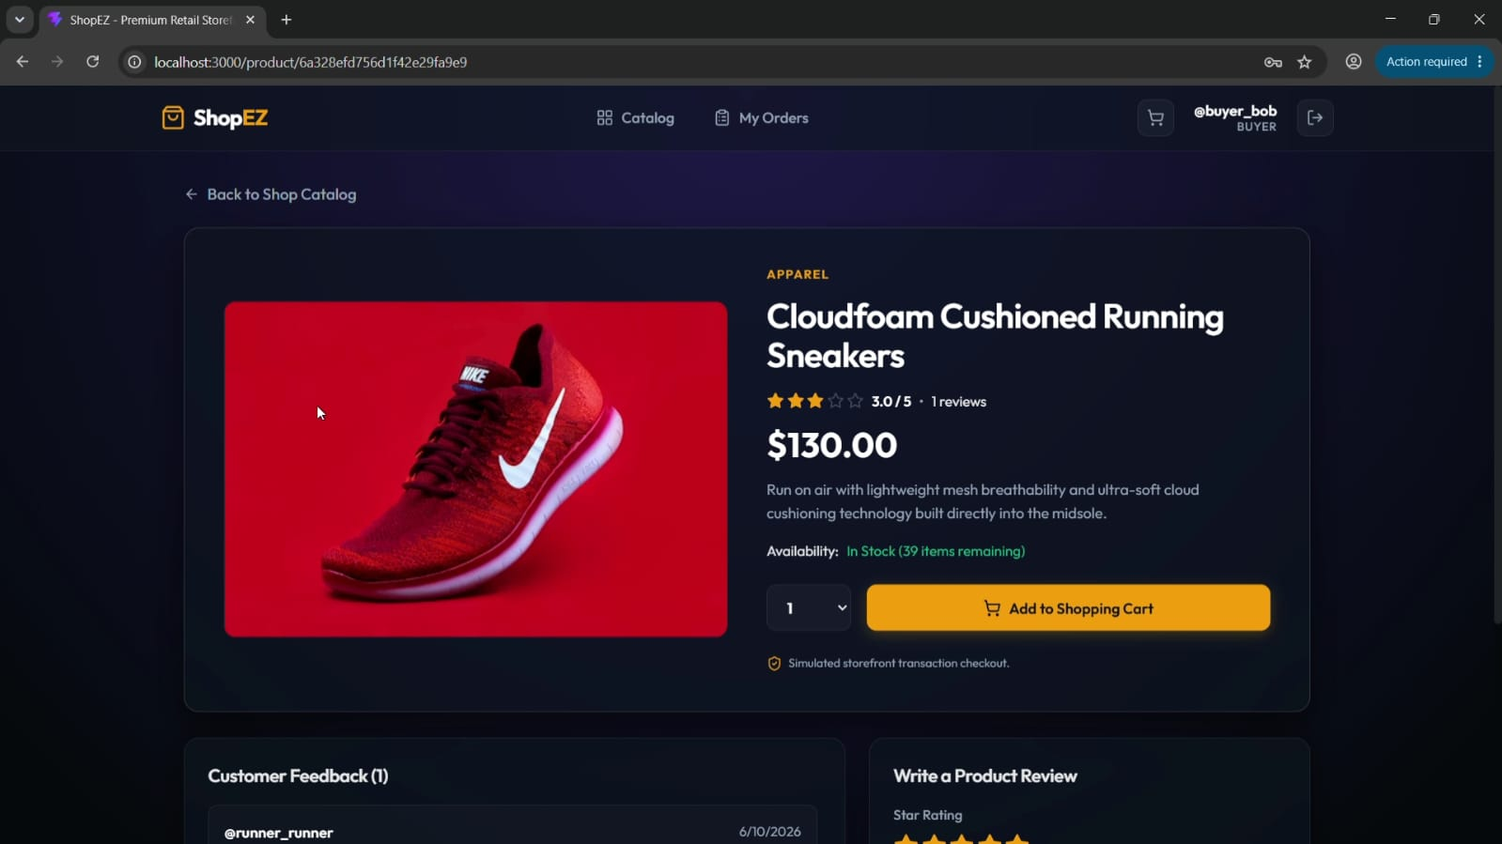

4. Cart Page
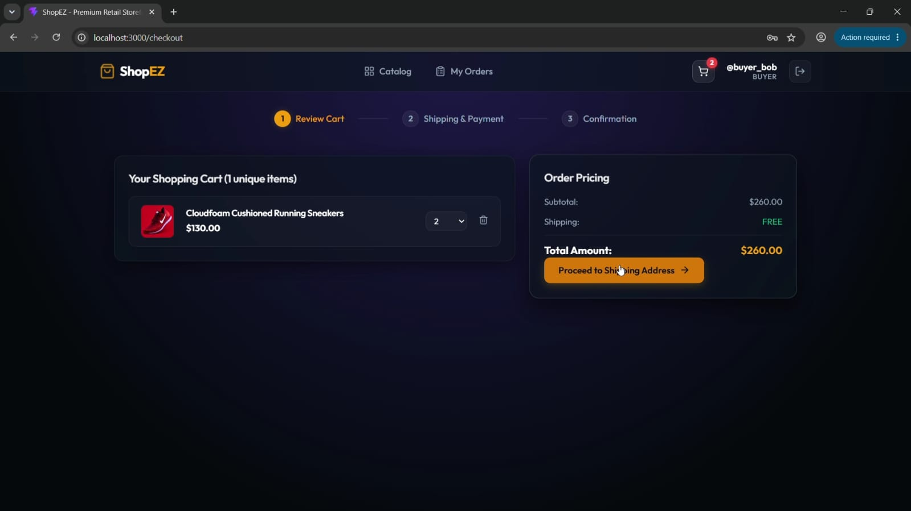

5. Seller Dashboard
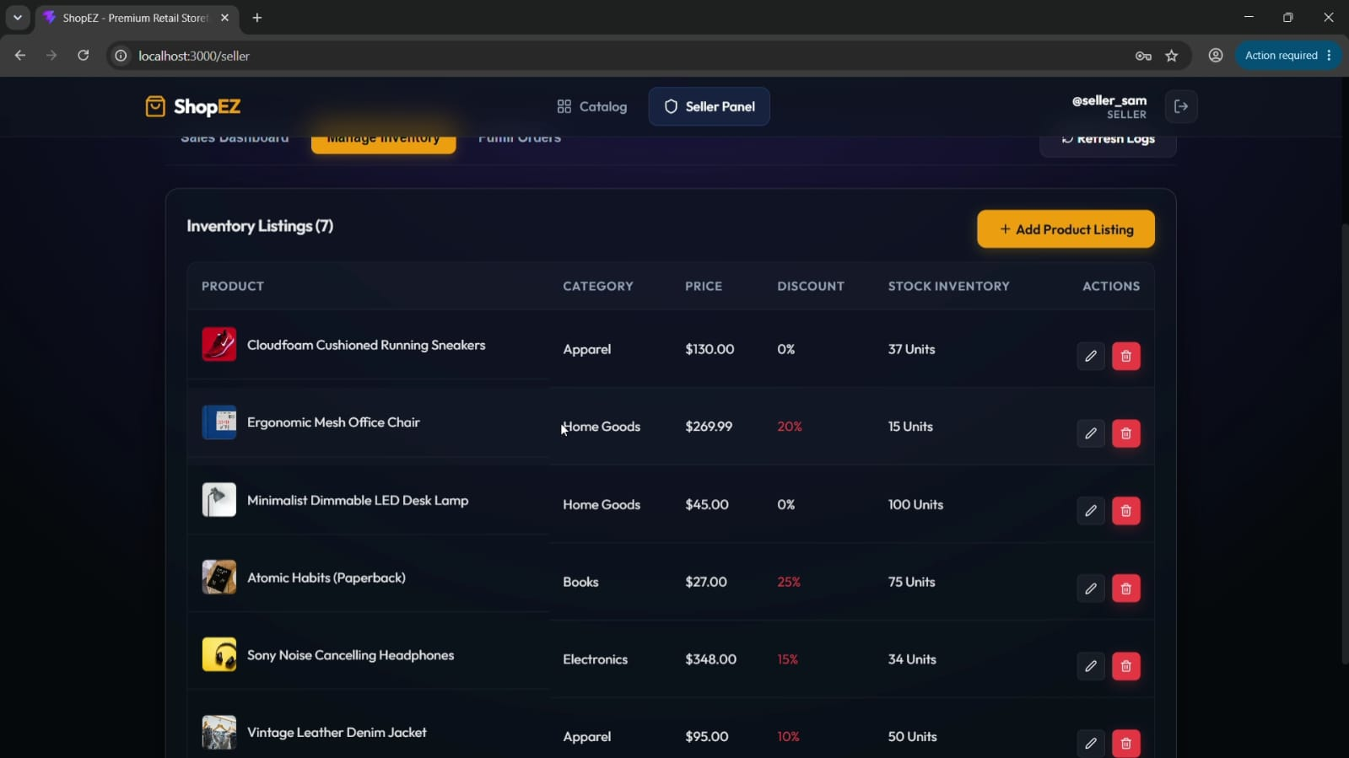

6. Orders Managements
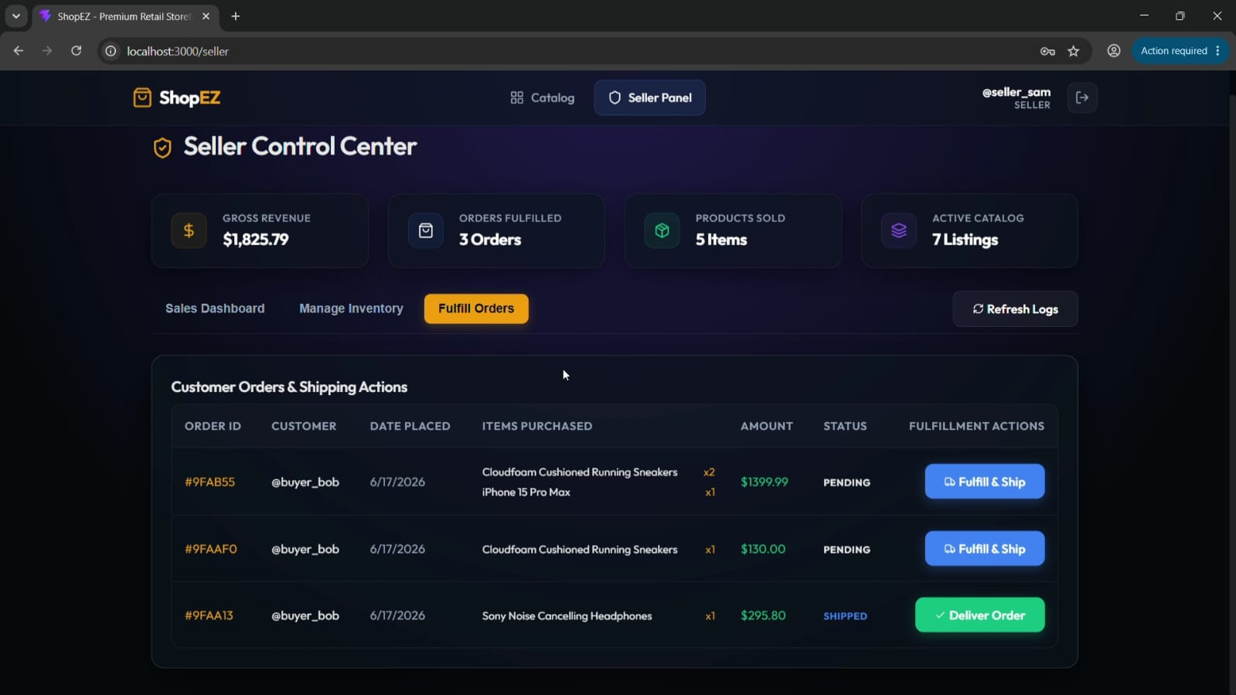

Page 12: Future Scope and Conclusion

Future Enhancements

Payment Gateway Integration
Integration with Stripe or PayPal.

Cloud Image Storage
Support for Cloudinary or AWS S3 image uploads.

Multi-Seller Order Splitting
Separate fulfillment tracking for multiple sellers.

Real-Time Chat
Communication between customers and sellers.

AI-Based Product Recommendations
Personalized product suggestions using machine learning.

Conclusion
ShopEZ successfully demonstrates the development of a modern full-stack e-commerce platform using React.js, Node.js, Express.js, and MongoDB. The application provides a complete online shopping experience with secure authentication, product management, order tracking, and seller analytics.
The project showcases practical implementation of MERN stack technologies, RESTful APIs, database management, authentication systems, and responsive web design. Through its comprehensive feature set and scalable architecture, ShopEZ serves as an effective e-commerce solution and a strong demonstration of full-stack web development skills.

